**What’s system design?**

Low level design covers the structure of code in a given component. However, a large scale system will have multiple components / services. High level design is about the optimal design of which components to have for a fast and efficient system. More on this later.

**Why do we need distributed systems?**

Let’s take a real story of a website that started on a single laptop in a dorm room (Exactly how we write code today). Back in 2003, there was a website that went by the name of Del.icio.us (<https://en.wikipedia.org/wiki/Delicious_(website)>).

Browsing the internet was completely based on bookmarks and you would lose bookmarks the moment you changed browser / machine. So, delicious built a bookmarking website. You login, and then bookmark websites using delicious tool. That way, when you go to any other machine/browser, all you need to do is to login into delicious with your account to get access to all your bookmarks. Basically, largely delicious implemented following 2 functions:

* addBookmark(userId, site_url)
* getAllBookmarks(userId)

If you were to code those 2 functions on your laptop, would you be able to? Assume you store entries in MySQL database which is also on your laptop.

If yes, congratulations. Your version of delicious is almost ready.

**Problem 1:** How do I ensure that when people type del.icio.us in their browsers, they reach my laptop?

The internet world only understands IP Address. How do people know the IP address of my laptop when they type del.icio.us?

How do you setup your personal website today?

* You go to GoDaddy to buy a domain.

Ok, but how does GoDaddy know which domain name is available? People can buy domains from GoDaddy / NameCheap / domains.google and tons of other websites.

There must be a central place maintaining domain names and their owners. And yes, there is. It’s called ICANN (The Internet Corporation for Assigned Names and Numbers). It’s non profit and has a directory of all registered domain names along with their owner details and the date validity.

Alright. But that still does not solve my problem. If I go to GoDaddy and buy delicious domain name, is my issue solved? A random user’s browser still does not know how to reach my laptop.

So, that means I should be able to associate my domain name to my laptop’s IP address. That is exactly what happens. You can create “A” record in GoDaddy / Namecheap that is then registered centrally.

* Further reading:
  + <https://www.namecheap.com/support/knowledgebase/article.aspx/319/2237/how-can-i-set-up-an-a-address-record-for-my-domain/>
  + <https://support.dnsimple.com/articles/differences-between-a-cname-alias-url/>

Ok, so now ICANN knows IP address of my laptop tied to delicious domain name that I bought.

Which means theoretically, when someone types delicious in their browser, they can get the IP address they need to go to from ICANN. But is that a good design?

Not really. ICANN becomes the single point of failure for the entire internet.

Ok, then what do we do? Imagine if there were thousands of machines all around the internet that had a copy of the information there on ICANN. Then my problem could have been solved. Because now people typing delicious on their browser, could find out the IP address from these machines.

Very simplistically, these machines are called DNS machines (Domain Name Servers). While the DNS architecture is decently complicated (You can read <https://support.dnsimple.com/articles/differences-between-a-cname-alias-url/> if interested), in simple words, DNS machines maintain a copy of information present centrally and they keep pinging every few hours to get any recent updates from the central machines.

*[Not spending time on DNS architecture since the class is not on DNS. We did the discussion to give an insight into how internet works].*

Ok, so now we are live. Delicious is now serving users.

There is a small problem though. Everytime I want to add new features and re-deploy and re-start my laptop with new code, delicious is unavailable for a few seconds. That’s not good. So, what do I do?

Maybe instead of one laptop, I have multiple laptops with same code and same information (We will figure out how to keep this information in sync). However, when my code is being deployed to a laptop X, how do I ensure no traffic is coming to X?

We need a Load Balancer which keeps track of laptops, which ones are running and is responsible to split the load equally.

How does Load balancer do that?

* Which machines are alive? - Heartbeat / Health Check
* Splitting load? - Round robin / Weighted Round Robin / Ip Hash

<https://docs.nginx.com/nginx/admin-guide/load-balancer/http-load-balancer/> has example of a config setup of a load balancer.

Imagine, Del.icio.us becomes majorly popular. It starts getting massive traffic. It starts getting a million new bookmarks every day.

Now, remember this is 2004. Best machines had 40GB hard disk. If you were getting 1 Million new bookmarks every day, and every bookmark is 200 bytes roughly, then you are adding 200MB of new bookmarks every day. Which means you will run out of space in 6 months. What do you do?

You will have to consider splitting the information you have between machines. This is called sharding.

**Step 1:** Choose sharding key. Basically what information should not get split between machines, and should reside in the same machine.

Show what happens if you choose site_url as the sharding key. getAllBookmarks has to go to all machines.

We choose user_id to be the sharding key, which means a user and all their bookmarks go to one shard.

**Step 2:** Build out an algo for userId -> shard mapping.

Following constraints:

* Finding shard given userID should be extremely lightweight. Can’t add a lot of load to LB.
* Load should be somewhat equally distributed (no load skew)
* Addition of new shards should be easy and should not cause major downtime.
* Same for removal of shards.

Let’s check certain approach for sharding.

* Approach 1: Assign userId to userId % number_of_shards. While this approach is great, it fails when number of shards change, as it causes almost every user’s data to be copied to another machine. Massive downtime when shard is added.
* Approach 2: Range based assignment. Load skew - first adopters more likely to be busier users. Also, every range’s total storage usage will only increase as they add more bookmarks. Addition of new shard does not help existing shards.

Let’s look at the real approach used in most cases - Consistent Hashing.

**Consistent Hashing**

Imagine a circle with points from [0, 10^18]. Imagine there is a hash function H1, which maps every machineId to a number in [0, 10^18], which you then mark on the circle. Similarly, there is another hash function H which maps userId to [0, 10^18].

Let’s assume we assign a user to be present on the first machine in the cyclic order from the hash of the user.

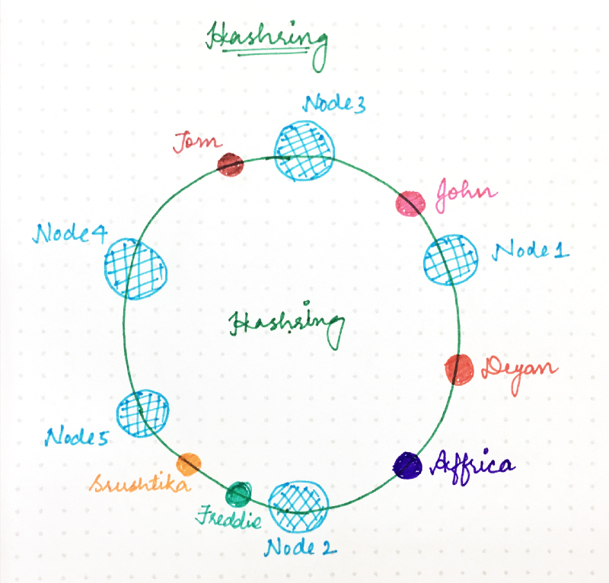

For example, in the diagram above, Deyan and Affrica are assigned to Node 2, Freddie and Srushtika on Node 5 and so on.

In implementation, if you have a sorted array with hashes of nodes, then for every user, you calculate the hash, and then binary search for the first number bigger than the given hash. That machine is what the user will be assigned to.

However, this design suffers from an issue. What happens when you remove a shard. Let’s say Node 2 is down. All load of Node 2 (Deyan + Africa) get assigned to Node 5 and Node5’s load basically doubles. At such high load, there is a good probability that Node 5 dies which will triple the load for Node 4. Node4 can also die and it will trigger cascading failure.

So, we modify the consistent hashing a little bit. Instead of one hash per machine, you use multiple hashing functions per machine (the more, the better). So, Node 1 is present at multiple places, Node 2 at multiple places and so forth.

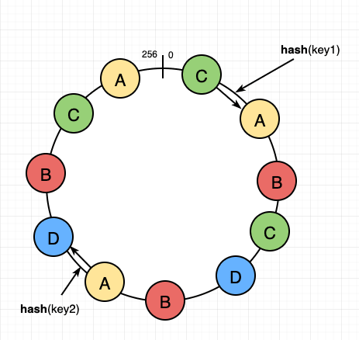

In the above example, if node A dies, some range of users is assigned to B, some to D and some to C. That is the ideal behavior.

**Guideline for future classes**

Following is a guideline on what the classes are going to be about and **not** about**:**

HLD classes are going to be about:

* Breaking down the complex terminologies and explain things bottom up.
* Not making assumption on seniority, but rather only assume deep knowledge of DSA, SQL, concurrency and LLD.
* Building a problem solving mindset to designing systems and not a knowledge heavy mindset.

HLD classes **not** going to be about:

* Teaching you knowledge of all existing systems. We will never be able to cover all possible software systems that exist in this world.
  + The focus would be rather to cover important patterns for HLD.
* Just like in DSA, we don’t necessarily teach you about libraries, very similarly the classes won’t cover syntax to use a particular system, but rather talk about their architecture. We will however share post lecture notes on specifics on how to use these systems.
  + Tech stacks come and go. Focus on developing the rationale of how you would build certain tech systems.